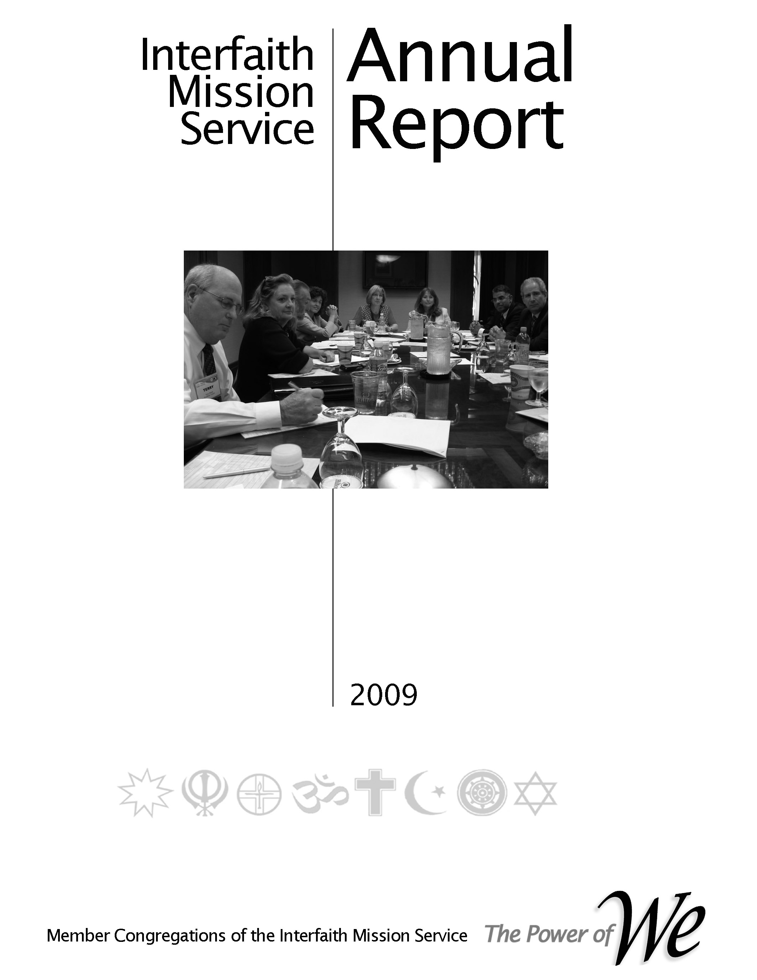

Governance
Committee Handbook
2017
Revised – 4/15/15
John,
There is not enough time to update all of the handbooks before our Sat retreat. Paragraphs 2.1.3 and 3.7cover the responsibilities of the MA and the MA manager. Please make a copy to use during Session I on Saturday.

Subsequent to this event the Governance Committee will incorporate the appropriate updates.

Aladin

Table of Contents

Preface, History & Organization

Committee Responsibilities

Job Descriptions

Processes
- Planning
- Reporting
- Operations

Annual Plan 2015
- Level II Schedule
- Catch-up Schedule
- Normal Schedule

Preface, History & Organization

Preface
In our 2009 reorganization the primary purpose was to reconnect the faith community’s congregations structurally with the operation of their cooperative. This was accomplished by reinstituting the Leadership Council (LC) whereby every member congregation had representation on the LC. Per our by-laws the LC is responsible for setting the direction of our cooperative by approving the strategic plan, annual plan with accompanying budget, electing officers and other leaders. One of the vital committees for ensuring that these responsibilities are accomplished is the Membership Standing Committee. Its mission is to assimilate the member congregations representatives (CR) into the life of the cooperative.
Practically, that entails understanding the desires and needs of our member congregations, informing them of the service learning opportunities (SLO), schedule of events and supporting their desire to take advantage of the benefits of being an owner of our cooperative.
That is the purpose of this Outreach Planning Handbook and the resulting congregation growth plan.
When interacting with member congregations the Membership Committee member must always keep in mind that the member congregation is an owner of the cooperative. As such the benefits provided by being a member are theirs already. Consequently, the Membership Committee member should avoid terms and phrases that a we/them relationship.

History
Why organized - to moving beyond relief to building community - from the beginning the founding congregation we wanting to reach beyond relief. Although the social situation was different and the terms used were different there was an underlying feeling that the outreach ministries of the faith community must address concerns beyond food, shelter, clothes, etc. Civil rights dominated the attention of our social conditions so there was a parallel effort begun to address those issues. Today we realized that outreach is a continuum from relief to systemic transformation.

- Mission & Vision - Our mission & vision are depicted in the adjacent picture. Several years ago the LC adopted a set of maxims derived from Peter Drucker’s “Managing a non-Profit”. The first maxim stated “The mission comes first”. The others followed to complete the management process. All those providing leadership in our cooperative should remain fixated on “The mission comes first”.

Organization
Our organization is designed to ensure that the member congregations are in control of the direction of the cooperative – in its strategic (long range) and tactical activities. This Operations Manual will provide the specifics.

From our Operations Manual

Organization Responsibilities – Leader Job Description – Processes

2.1.3 Governance Standing Committee
The Governance Committee is the standing committee that has the responsibility for developing and maintaining governance policies and procedures, nominations to meet by-law requirements, ensuring via training and policies that all leaders of the cooperative are meeting performance and best practice expectations and maintaining the Operations Plan.
1. Develop and maintain the Operations Plan.
2. Ensure that the governing documents address all requirements and best practices needed by a non-profit enterprise
3. Develop and conduct training events to ensure all of the key leadership understand the Articles of Incorporation, by-laws, strategic plan, annual plan and other policies used to achieve the cooperative’s mission and vision.
4. Conduct or cause the conduction of audits and assessments needed to obtain the highest quality of management performance.
5. Draft a function and responsibility progression plan to develop the leaders of the cooperative.
6. Ensure that, prior to accepting a leader role in the cooperative’s operation, all persons understand the responsibilities and are prepared to make the commitment. An aid to this task is to ensure that there are clear and detailed job descriptions for all of the leadership positions.
7. Ensure that the leadership council and board regularly engages in self-assessment and evaluations.
8. Assist the LC and board in periodically updating and clarifying the primary areas of focus for the board, and help shape the board’s agenda for the next year or two, based on the strategic plan.
9. Lead in assessing the needs related to board composition, determining the knowledge, attributes, skills, abilities, influence, and access to resources the LC and board will need to consider to accomplish future work of the board.

10. Perform the nominating functions needed to meet by-law requirements. In addition and perhaps more important is to employ a process that matches qualifications with each service learning opportunity (SLO). Board Source materials have identified Seven Sins of Boardmanship that also apply to all of the organizational element leadership SLOs in our cooperative.
Seven Sins of Boardmanship
- Acceptance without commitment.
- Membership without attendance.
- Affiliation without dedication.
- Meetings without participation.
- Decisions without integrity.
- Involvement without advocacy.
- Association without giving.

11. Prepare letters to the leaders of the organizational elements to provide them with the necessary documents needed to fulfill their responsibilities.

The Governance Committee is a committee of the Leadership Council and reports to the Leadership Council Chair. The leader of the Governance Committee is a member of the LC Executive Committee.

3.7 Governance Standing Committee Leader Job Description

1. Prepares letters, for the LC Chair’s signature, to all of his/her direct reports. See appendix

Our by-laws state that our cooperative is “a multi-faith organization whose members seek to grow and maximize their capacity to meet human needs, promote religious, racial and cultural harmony and participate in the public square to improve our community.”

Our desired operating concept is for member congregations to “Plan the work and work the plan”. In our context this phrase means that the member congregations will have a major input to the strategic plan that drives the annual plan and their representatives will approve the annual plan. To implement the annual plan the member congregations will take responsibility for major segments.

When this operating concept is implemented a member congregation would be the Coordinating Congregation and other congregations could be Support Congregations. To put this operating concept in place it generally starts with an individual that is willing to enlist the participation of his/her congregation.
Processes

General Planning Process

4.1 Strategic and Annual Planning
The figure on the right depicts our strategic and annual planning process. The term Accountable Planning is used to make the point that the detail planning should advance the mission and vision of the cooperative.
The steps involved to execute the strategic and annual planning processes are:
Strategic Planning
Step 1. In Feb/Mar the Strategic Planning Committee will notify the board of directors of the next year’s strategic goals.
Step 2. The committee will update the strategic plan using the guidance from, our governing documents, member congregations, community growth and needs assessments and community needs assessment, ministry areas/ministries, individual members and previous five year plan.
Step 3. The new strategic plan will be presented to the LC for approval in

4. 2 Monthly Report Process

4.3 Governance Standing Committee Processes

4.4 Governance Standing Committee Schedules

Level II Plan
Goals

Service Learning Opportunities

