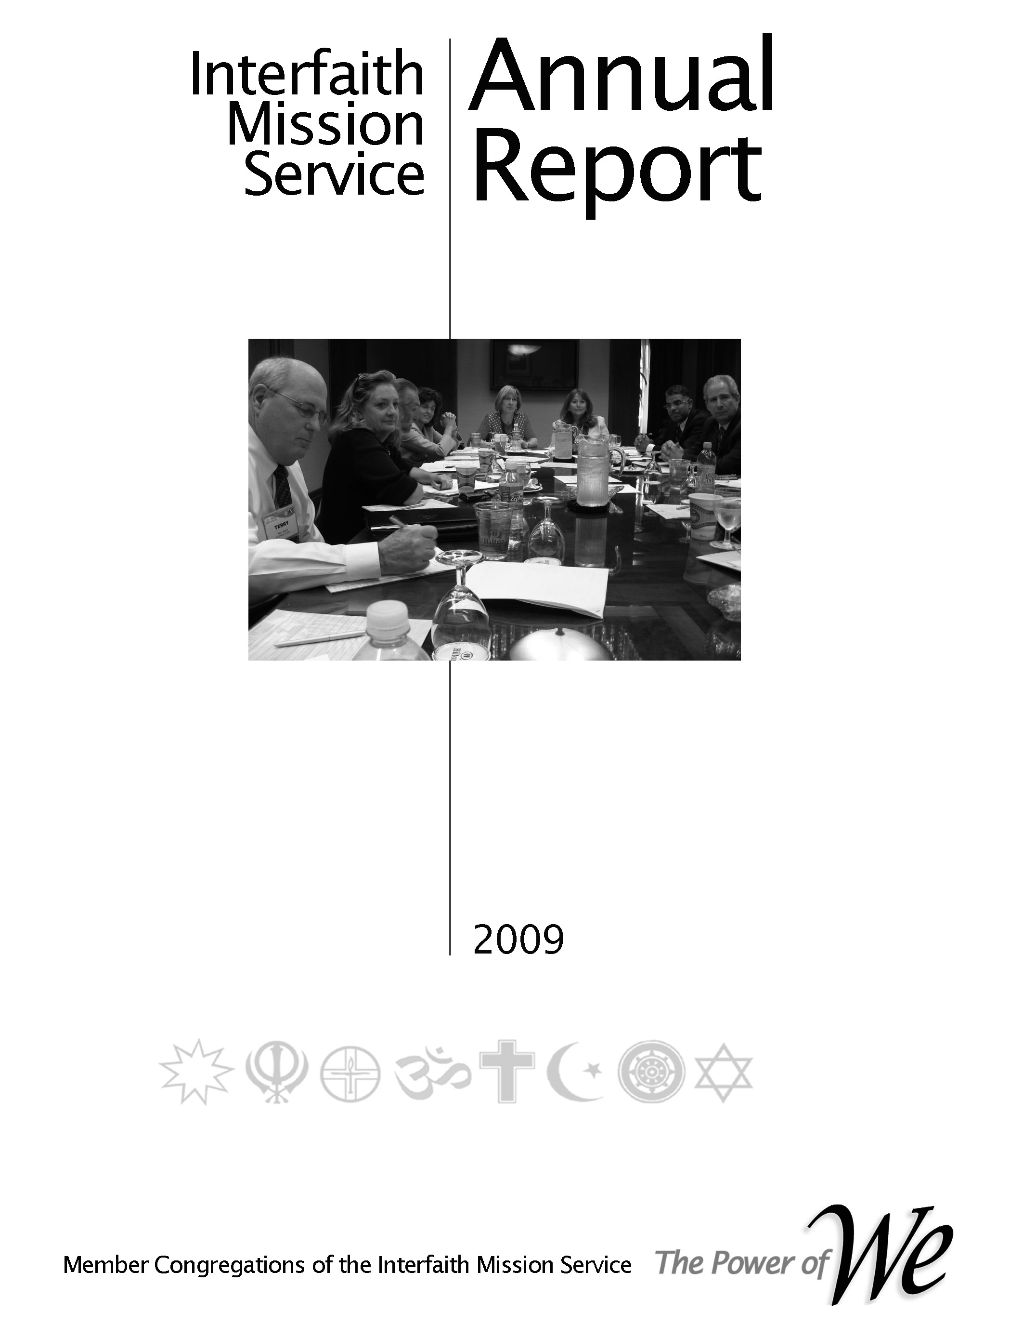

#### Membership

**Committee Handbook**

**Table of Contents**

Willie,

There is not enough time to update all of the handbooks before our Sat retreat. Paragraphs 2.1.1 and 3.5 cover the responsibilities of the MA and the MA manager. Please make a copy to use during Session I on Saturday.

Subsequent to this event the Governance Committee will incorporate the appropriate updates.

Aladin

Updated – 1/4/17

**2017**

# Purpose

**Scope**

# Preface, History & Organization

# Committee Responsibilities

# Job Descriptions

# Processes

* Planning
* Reporting
* Operations

##### Annual Plan 2015

* Level II Schedule
* Catch-up Schedule
* Normal Schedule

**Purpose**

The purpose of this document is to provide an operational handbook for orienting, training and guiding the members of the Membership Committee and others that will interact with the committee members in the course of performing their responsibilities.

**Scope**

There are two primary sources for the information herein.

1. The Operations Manual –This is the “parent” document for delineating committee responsibilities, leader and member responsibilities, processes and other pertinent information used to direct and guide the committee.
2. The Interfaith Mission Service annual plan and supporting budget – This is the “parent” document for setting forth the committee’s Level I and II plans, budget and other pertinent information used to direct and guide the committee.

The parent documents are approved by the Leadership Council (LC) and are thus binding on the committee. Level III planning and other information must be aligned with the Operations Manual and annual plan, but does not have to be approved by the LC.

Both parent documents, as well as this document, can be accessed via <interfaithmissionservice.org>; select Admin; and then Plans and Governing Documents.

**Preface, History & Organization**

**Preface**

In our 2009 reorganization the primary purpose was to reconnect the faith community’s congregations structurally with the operation of their cooperative. This was accomplished by reinstituting the Leadership Council (LC) whereby every member congregation had representation on the LC. Per our by-laws the LC is responsible for setting the direction of our cooperative by approving the strategic plan, annual plan with accompanying budget, electing officers and other leaders. One of the vital committees for ensuring that these responsibilities are accomplished is the Membership Standing Committee. Its mission is to assimilate the member congregations representatives (CR) into the life of the cooperative.

Practically, that entails understanding the desires and needs of our member congregations, informing them of the service learning opportunities (SLO), schedule of events and supporting their desire to take advantage of the benefits of being an owner of our cooperative.

That is the purpose of this Outreach Planning Handbook and the resulting congregation growth plan.

When interacting with member congregations the Membership Committee member must always keep in mind that the member congregation is an owner of the cooperative. As such the benefits provided by being a member are theirs already. Consequently, the Membership Committee member should avoid terms and phrases that a we/them relationship.

**History**

Why organized - to moving beyond relief to building community - from the beginning the founding congregation we wanting to reach beyond relief. Although the social situation was different and the terms used were different there was an underlying feeling that the outreach ministries of the faith community must address concerns beyond food, shelter, clothes, etc. Civil rights dominated the attention of our social conditions so there was a parallel effort begun to address those issues. Today we realized that outreach is a continuum from relief to systemic transformation.



**Mission Statement of our inter-religious cooperative, the Interfaith Mission Service**

**Our Mission**: **To strengthen and enhance our member congregations capabilities to:**

* Meet human needs,
* Participate in the public forum,
* Promote religious, racial and cultural harmony

**Vision Statement of our inter-religious cooperative, the Interfaith Mission Service**

To become globally recognized leaders in building beloved community

**Characterization of Beloved Community**

* Poverty, hunger, and homelessness are not tolerated because international standards of human decency do not allow it
* Racism and all forms of discrimination, bigotry and prejudice are replaced by an all-inclusive spirit of sisterhood and brotherhood.
* Disputes will be resolved by peaceful conflict-resolution and reconciliation of adversaries, instead of force.
* Economic inequality will be replaced by economic justice
* Mission & Vision - Our mission & vision are depicted in the adjacent picture. Several years ago the LC adopted a set of maxims derived from Peter Drucker’s “Managing a non-Profit”. The first maxim stated “The mission comes first”. The others followed to complete the management process. All those providing leadership in our cooperative should remain fixated on “The mission comes first”.

##### Organization

Our organization is designed to ensure that the member congregations are in control of the direction of the cooperative – in its strategic (long range) and tactical activities. The Operations Manual will provide the specifics.

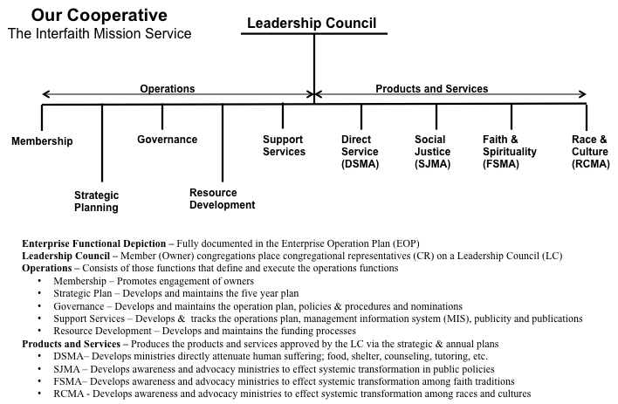

* Member congregations (often referred to as owners) select a member(s) of their congregation to represent them on our cooperative’s Leadership Council.
* The Board of Directors and five standing committees report to the Leadership Council.
* The functions of all of the organizational elements are defined in the Operations Plan. The Membership Standing Committee functions are repeated in this document

**Organization Responsibilities – Leader Job Description – Processes**

# 2.1.1 Membership Standing Committee

A properly functioning membership cultivation team is vital to successful accomplishment of our cooperative’s mission and vision statements. To execute this responsibility a Membership Standing Committee has been created. Its responsibility is to recruit and nurture members as prescribed by the by-laws. The by-laws have provisioned for five classes of members; see Article II, Interfaith Mission Service By-laws, March 2009. The following major functions apply to those classes.

1. General
   1. Maintaining a prioritized (from least likely to most likely) potential member list to be used to contact new members Provide presentation requirements to the Support Services Ministry Area to enable them to develop presentations for potential and existing member congregations
   2. Provide presentation requirements to the Support Services Ministry Area to enable them to develop presentations for potential and existing member congregations
   3. Review and update application forms when necessary
   4. Work with the strategic committee to devise a member input survey and follow up with the members to ensure they take advantage of the opportunity to have an input. Help analyze the results.
   5. Work with the office to define the information needed to populate the management information system MIS.
   6. Coordinate with the Strategic Planning and Support Systems Standing Committees during their planning cycles to ensure that they are involved at the proper times.
2. Congregations
   1. Using the planning roadmap tool (see Section 4.0 Processes) devise a plan whereby members of the committee are responsible for contacting potential member congregations and maintaining contact with existing congregations
   2. Meet with the representatives of the member congregations to determine their desires for their outreach ministries e.g. what ministries do they have, what ministries would they like to have, do they have a long range plan for their outreach ministries.
   3. Develop a model of a robust outreach program that can be used to evaluate the programs of member congregations.
   4. Find out the major events the member congregations would like to see publicized on the cooperative’s web site.
   5. Coordinate with the Strategic Planning and Support Systems Standing Committees during their planning cycles to ensure that the
3. Advisory Members - TBS
4. Individual/Student/Youth
   1. Develop a robust individual membership program based on an annual renewal cycle
5. Supporting Members - TBS

The Membership Committee is a committee of the Leadership Council and reports to the Leadership Council Chair. The leader of the Membership Committee is a member of the LC Executive Committee.

**3.5 Membership Standing Committee Leader Job Description**

Our by-laws state that our cooperative is “a multi-faith organization whose members seek to grow and maximize their capacity to meet human needs, promote religious, racial and cultural harmony and participate in the public square to improve our community.”

Our desired operating concept is for member congregations to “Plan the work and work the plan”. In our context this phrase means that the member congregations will have a major input to the strategic plan that drives the annual plan and their representatives will approve the annual plan. To implement the annual plan the member congregations will take responsibility for major segments.

When this operating concept is implemented a member congregation would be the Coordinating Congregation and other congregations could be Support Congregations. To put this operating concept in place it generally starts with an individual that is willing to enlist the participation of his/her congregation.

In general the duties of the Membership SC are to ensure that the responsibilities defined in Paragraph 2.1.1 are implemented.

More specifically and in the vein of guidance;

1. The Membership SC Chair should establish a steering team (7-9 persons) to lead the committee. All CRs are expected to perform the role of being the link between their congregation and the cooperatives ministries, the steering team should consist of CRs and others if needed. The CRs not on membership steering team should be involved with the work of the SCs and MAs.

2. The Chair shall be very familiar with all of the processes explained in Section 4 and will ensure that all members of his/her team are equally familiar. Of particular importance are the planning and reporting processes. Adequate and timely planning plus committed leadership are the keys to the success of our cooperative. Reporting performance establishes the creditability for financial support.

3. By August of each year contact each member congregation and arrange to explain the succeeding years ministry plan and supporting budget. The application for membership renewal will be presented at that time.

4. Work with the Strategic Planning Committee to determine when the member congregations will be asked for inputs to the strategic plan. Provide an input to the composition of the survey to be conducted. Follow up with the member congregations to encourage their participation in the survey.

5. As stated in our by-laws, the purpose of the cooperative is to help member congregations increase their capability and capacity to conduct outreach ministries to the community. As an aid to that purpose, generate a description of a model outreach ministry that can be used by congregations to evaluate their outreach ministries.

6. When contacting member and potential member congregations collect the names and contact information of their key personnel. The key personnel positions are identified in the existing management information system (MIS) database.

7. The MIS contains participation information relative to the ministries of the cooperative. The leader will organize the committee to provide the needed information to the ministry area leaders.

8. Visiting teams for members and potential members

9. Scheduling for MA ministries (work with)

10. The leader will ensure that at least two special topic luncheons (or other gatherings) are organized for clergy and key personnel. The topics may address policy matters on which the Leadership Council solicits advise, the ministry areas, special events, etc.

11. The leader will ensure that a list of potential member congregations are maintained. The list will be prioritized from least likely to most likely to join.

12. The leader will ensure that requirements for presentation materials are provided to the Support Services Ministry Team for development.

13. The leader will recruit a member congregation to accept responsibility for implementing the functions of Membership Committee. When that occurs the leader will take the lead to develop Coordinating Congregation Description (CCD) using the format of those already in existence.

**3.1 Congregational Representative (CR)**

The CRs are named to the LC by the member congregation and are their congregations connecting link with our cooperative. All CRs are expected to accept a service learning opportunity (SLO) provided by one of the standing committees or ministry areas.

More specific responsibilities are to represent their congregation by:

1. Providing information about their congregation e.g. ministries, congregation leaders, interests, etc. Some of this is accomplished via the membership application form. During the course of the year other information may be needed to accomplish the mission of the cooperative.

2. Each of the ministry areas have specific ministries designed to help our owner congregations grow their outreach capability and capacity. The CRs are to publicize these opportunities within their congregations and in many cases establish small group studies, conversational sessions, presentations, etc.

3. Generating and implementing the ministries, mentioned above, create many service learning opportunities (SLO). The CR is depended upon to communicate these SLOs within their congregation. It is through this process that our congregations will increase their capability and capacity for engaging our community.

4. A major function of the LC is to provide future direction for our cooperative. Input from our owner congregations is vital for this task as well as input from the community and established ministry areas. An event to collect and compile information for updating the Strategic Plan occurs in the spring. The CRs are expected to represent their congregation’s views.

**Processes**

# General Planning Process

# 4.1 Strategic and Annual Planning

The figure on the right depicts our strategic and annual planning process. The term Accountable Planning is used to make the point that the detail planning should advance the mission and vision of the cooperative.

The steps involved to execute the strategic and annual planning processes are:

**Strategic Planning**

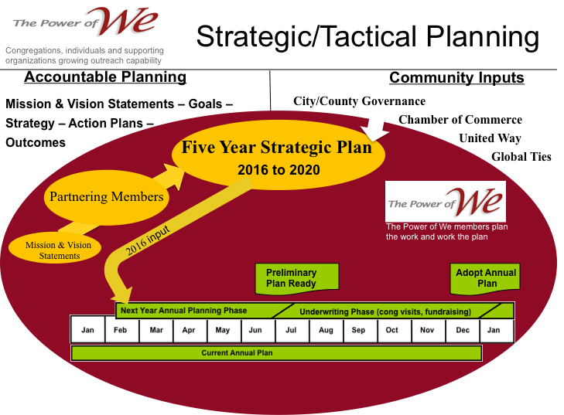Step 1. In Feb/Mar the Strategic Planning Committee will notify the board of directors of the next year’s strategic goals.

Step 2. The committee will update the strategic plan using the guidance from, our governing documents, member congregations, community growth and needs assessments and community needs assessment, ministry areas/ministries, individual members and previous five year plan.

Step 3. The new strategic plan will be presented to the LC for approval in

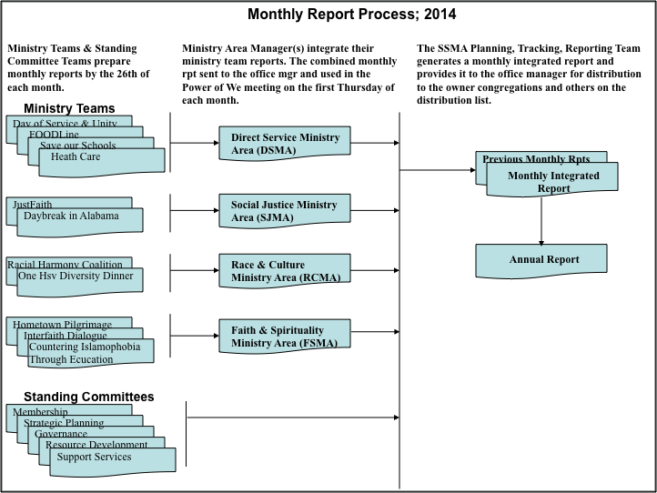**\4.2 Monthly Report Process**

**4.3 Member & Potential Member Contact Process**

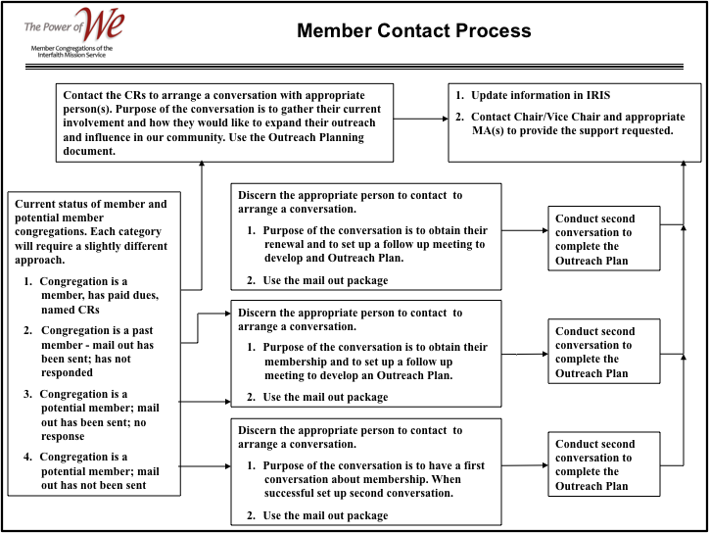Currently, our records depicting the status congregations affiliated with our cooperative are not definitive. The Membership Committee is gearing up to rectify that condition through a more clearly define process presented in Figure 1.

Step 1- Define the status of each congregation that is considered a cooperating member and those that are considered likely potential members. This has been accomplished and are defined by 1, 2, 3, 4 in the process diagram.

Step 2 - Arrange a conversation with the appropriate individual(s) to discuss how their congregation would like to take advantage of the opportunities offered by their membership. This results in and operations plan for each congregation.

Step 3 - Notify the Chair/Vice Chair of the Board of Directors (BoD) of the support requested by the congregation via their outreach plan. The Chair or member of the Membership Committee will send the results of the outreach planning conversation to the Chair/Vice Chair and appropriate MA manager.

|  |  |  |  |  |  |  |  |  |  |  |  |  |  |
| --- | --- | --- | --- | --- | --- | --- | --- | --- | --- | --- | --- | --- | --- |
| **Objectives** | **Strategy** | **Jan** | **Feb** | **Mar** | **Apr** | **May** | **Jun** | **Jul** | **Aug** | **Sep** | **Oct** | **Nov** | **Dec** |
| Organize a Membership Profile Database |  |  |  |  |  |  |  |  |  |  |  |  |  |
| Organize Annual Celebration & Awards Dinner (ACAD) |  |  |  |  |  |  |  |  |  |  |  |  |  |
| Provide our membership with an understanding of the future challenges to the faith community |  |  |  |  |  |  |  |  |  |  |  |  |  |
| 4. IMS Interfaith Sacred Poetry Competition |  |  |  |  |  |  |  |  |  |  |  |  |  |
| Fully staff our volunteer positions |  |  |  |  |  |  |  |  |  |  |  |  |  |
| Host events to promote relationships among the member congregations and to provide them opportunities to participate in IMS projects |  |  |  |  |  |  |  |  |  |  |  |  |  |
| Increase congregational membership 5% |  |  |  |  |  |  |  |  |  |  |  |  |  |
| Increase congregational participation in leadership and mission of IMS |  |  |  |  |  |  |  |  |  |  |  |  |  |

Step 4 - With this step the implementation process is the responsibility of the BoD Chair/Vice Chair and appropriate MA. The MA will contact the congregation’s point of contact (POC) and schedule the support e.g. JustFaith curriculum, Daybreak in AL study, Interfaith Dialogue, Multicultural Engagement Training, etc.

##### 4.4 Individual Member Contact Process

**4.5 Congregational Representative Assimilation Process**

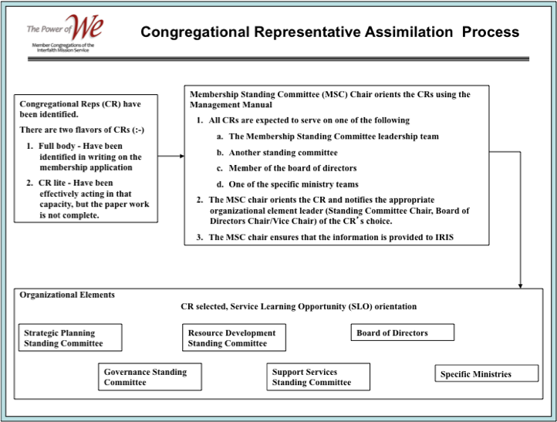“All congregational representatives CRs are expected to accept s service learning opportunity (SLO) provided by one of the standing committees or ministry areas” - see paragraph 3.1 of our Operations Plan.

All individual members will be offered the same opportunity although this is not prescribed by our current policies.

Step 1- Members of the Membership Standing Committee will organize and conduct an orientation session for the CRs and individual members. We have several new CRs and individual members at this time. Ministry area managers and others may be invited to participate in the orientation session(s).

Step 2 - Upon completion of the orientation session the CRs and individual members will select a SLO.

Step 3 - The Chair or member of the Membership Committee will send their selections to leader of the selected organizational element.

Step 4 - With this step the implementation process is the responsibility of the Standing Committee Chair, the BoD Chair/Vice Chair and appropriate MA. Each organizational element leader will notify the CR and/or individual member to convey their standard meeting time and provide additional details concerning the status of their ministries.

**5.0 Annual Plan for 2020**

|  |  |  |  |  |  |  |  |  |  |  |  |  |
| --- | --- | --- | --- | --- | --- | --- | --- | --- | --- | --- | --- | --- |
| **Tactics** | **Jan** | **Feb** | **Mar** | **Apr** | **May** | **Jun** | **Jul** | **Aug** | **Sep** | **Oct** | **Nov** | **Dec** |
| 1. Send Membership Renewal forms  2. Generate Profile Form  3. Generate Filemaker database  4. Conduct session(s) with the POW network members to gather the information |  | **15**  **15**  **15** | **1** |  |  |  |  |  |  |  |  |  |
| 1. Generate theme & keynote feature (speaker, panel, other) 2. Select venue 3. Follow the ACAD Planning Manual |  | **15**  **15** | **1** |  |  |  |  |  |  |  |  |  |
| Provide our membership with an understanding of the future challenges to the faith community |  |  |  |  |  |  |  |  |  |  |  |  |
| 4. IMS Interfaith Sacred Poetry Competition |  |  |  |  |  |  |  |  |  |  |  |  |
| Fully staff our volunteer positions |  |  |  |  |  |  |  |  |  |  |  |  |
| Host events to promote relationships among the member congregations and to provide them opportunities to participate in IMS projects |  |  |  |  |  |  |  |  |  |  |  |  |
| Increase congregational membership 5% |  |  |  |  |  |  |  |  |  |  |  |  |
| Increase congregational participation in leadership and mission of IMS |  |  |  |  |  |  |  |  |  |  |  |  |

**5.2. Level II Plan –**

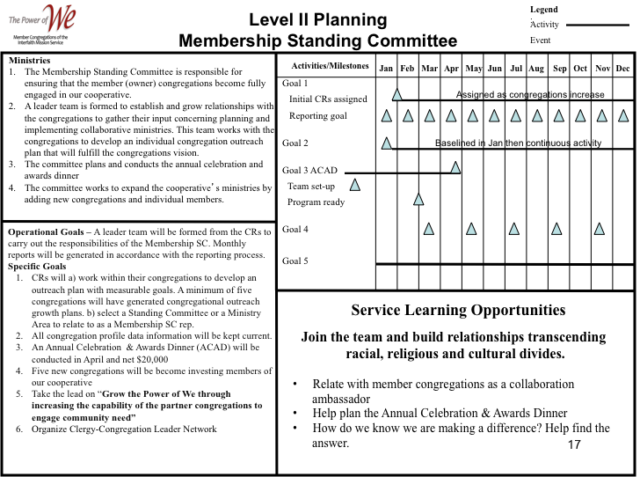

**Goals**

**Operational Goals –** A leader team will be formed from the CRs to carry out the responsibilities of the Membership SC. Monthly reports will be generated in accordance with the reporting process.

**Specific Goals**

A placeholder at this time; will be updated

* 1. CRs will a) work within their congregations to develop an outreach plan with measurable goals. A minimum of five congregations will have generated congregational outreach growth plans. b) select a Standing Committee or a Ministry Area to relate to as a Membership SC rep.
  2. All congregation profile data information will be kept current.
  3. An Annual Celebration & Awards Dinner (ACAD) will be conducted in April and net $20,000
  4. Five new congregations will be become investing members of our cooperative
  5. Take the lead on “**Grow the Power of We through increasing the capability of the partner congregations to engage community need”**
  6. Organize Clergy-Congregation Leader Network

**5.3. Level III Plan –** See Membership Committee Level III Plan. Accessible via the Interfaith Mission Service website; [interfaithmissionservice.org.;](interfaithmissionservice.org.%3B) admin; Plans and Governing Documents

**Appendix**

**Useful information for interacting with ecumenical and other faith traditions.**

This section of the handbook it to provide information about the various denominations and faith traditions that members of the MC leadership team need to become familiar with prior to conducting a listening session and/or other interactions.

**United Methodist Congregations**

**¶120. *The Mission (Book of Discipline)***

The mission of the Church is to make disciples of Jesus Christ for the **transformation** **of the world** by proclaiming the good news of God’s grace and by exemplifying Jesus’ command to **love God and neighbor**, thus seeking the fulfillment of God’s reign and realm in the world.

The fulfillment of God’s reign and realm in the world is the vision Scripture holds before us.

The United Methodist Church affirms that Jesus Christ is the Son of God, the Savior of the world, and the Lord of all.

As we make disciples, we **respect persons of all religious faiths and we defend religious freedom for all persons**. Jesus’ words in Matthew provide the Church with our mission:

“Go therefore and make disciples of all nations, baptizing them in the name of the Father and of the Son and of the Holy Spirit, and teaching them to obey everything that I have commanded you” (28:19-20), and **“You shall love the Lord your God with all your heart, and with all your soul, and with all your mind. . . . And you shall love your neighbor as yourself” (22:37, 39).**

**121. *Rationale for Our Mission***

This mission is our grace-filled response to the Reign of God in the world announced by Jesus. God's grace is active everywhere, at all times, carrying out this purpose as revealed in the Bible. It is *expressed* in God's covenant with Abraham and Sarah, in the Exodus of Israel from Egypt, and in the ministry of the prophets. It is fully *embodied* in the life, death, and resurrection of Jesus Christ. It is *experienced* in the ongoing creation of a new people by the Holy Spirit.

John Wesley, Phillip Otterbein, Jacob Albright, and our other spiritual forebears understood this mission in this way. Whenever United Methodism has had a clear sense of mission, God has used our Church to save persons, heal relationships, transform social structures, and spread scriptural holiness, thereby changing the world. In order to be truly alive, we embrace Jesus' mandate to love God and to love our neighbor and to make disciples of all peoples.

**Definition of the outreach ministries congregations “shall” address**

¶ 252.2 The outreach ministries of the congregation shall give attention to but not be limited to local and larger community ministries of compassion, justice, and advocacy. These ministries include church and society, global ministries, higher education and campus ministry, health and welfare, Christian unity and inter-religious concerns, religion and race, and the status and role of women.

Paragraph 252.2.b of our Book of Discipline states the following concerning outreach ministries

“The outreach ministries of the congregation shall give attention to but not be limited to local and larger community ministries of compassion, justice, and advocacy. These ministries include

1. church and society,
2. global ministries, (*interpreted to include local, state, regional as well as global)*
3. higher education and campus ministry,
4. health and welfare,
5. Christian unity and inter-religious concerns,
6. religion and race, and
7. the status and role of women.

Commentary on **¶**252 **–** There a very few congregations that can, individually conduct a robust ministry in all of these ministry areas. At the same time most congregations have members that are called to system ministries – reaching beyond direct service and addressing the “Why” questions. Thus, through the “Power of We” concept