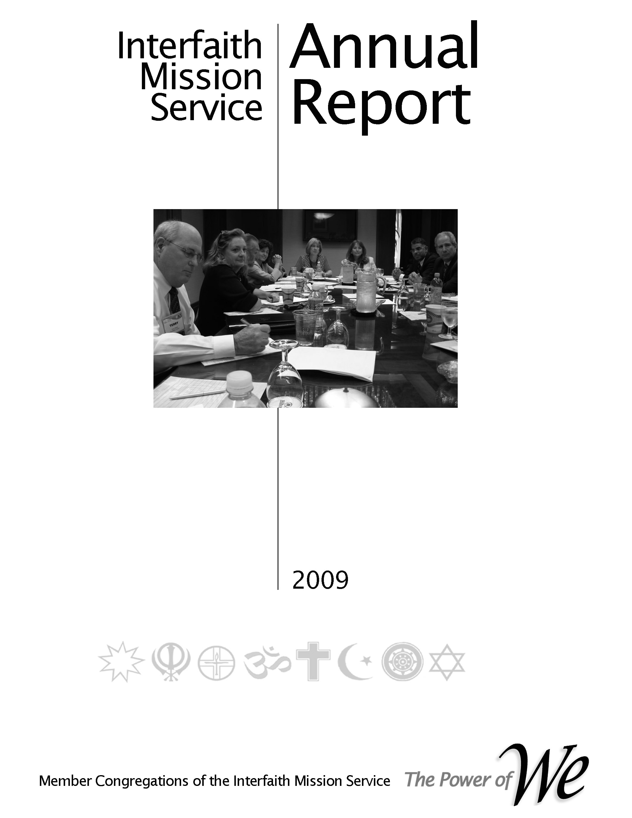
Social Justice Ministry Area (SJMA) Handbook
http://www.illustrationsof.com/royalty-free-rf-strategic-planning-clipart-illustration-by-macx-stock-sam
2017
Patricia,
There is not enough time to update all of the handbooks before our Sat retreat. Paragraphs 2.1.6.4 and 3.16 cover the responsibilities of the MA and the MA manager.

Subsequent to this event the Governance Committee will incorporate the appropriate updates.

Aladin

Table of Contents

Preface, History & Organization

Committee Responsibilities

Job Descriptions

Processes
Planning
Reporting
Operations

Preface, History & Organization

Preface
In our 2009 reorganization the primary purpose was to reconnect the faith community’s congregations structurally with the operation of their cooperative. This was accomplished by reinstituting the Leadership Council (LC) whereby every member congregation had representation on the LC. Per our by-laws the LC is responsible for setting the direction of our cooperative by approving the strategic plan, annual plan with accompanying budget, electing officers and other leaders. One of the vital committees for ensuring that these responsibilities are accomplished is the Membership Standing Committee. Its mission is to assimilate the member congregations representatives (CR) into the life of the cooperative.
Practically, that entails understanding the desires and needs of our member congregations, informing them of the service learning opportunities (SLO), schedule of events and supporting their desire to take advantage of the benefits of being an owner of our cooperative.
That is the purpose of this Outreach Planning Handbook and the resulting congregation growth plan.
When interacting with member congregations the Membership Committee member must always keep in mind that the member congregation is an owner of the cooperative. As such the benefits provided by being a member are theirs already. Consequently, the Membership Committee member should avoid terms and phrases that a we/them relationship.

History

Why organized - to moving beyond relief to building community - from the beginning the founding congregation we wanting to reach beyond relief. Although the social situation was different and the terms used were different there was an underlying feeling that the outreach ministries of the faith community must address concerns beyond food, shelter, clothes, etc. Civil rights dominated the attention of our social conditions so there was a parallel effort begun to address those issues. Today we realized that outreach is a continuum from relief to systemic transformation.
Mission Statement of our inter-religious cooperative, the Interfaith Mission Service
Our Mission: To strengthen and enhance our member congregations capabilities to:
Meet human needs,
Participate in the public forum,
Promote religious, racial and cultural harmony

Vision Statement of our inter-religious cooperative, the Interfaith Mission Service
To become globally recognized leaders in building beloved community
Characterization of Beloved Community
Poverty, hunger, and homelessness are not tolerated because international standards of human decency do not allow it
Racism and all forms of discrimination, bigotry and prejudice are replaced by an all-inclusive spirit of sisterhood and brotherhood.
Disputes will be resolved by peaceful conflict-resolution and reconciliation of adversaries, instead of force.
Economic inequality will be replaced by economic justice

- Mission & Vision - Our mission & vision are depicted in the adjacent picture. Several years ago the LC adopted a set of maxims derived from Peter Drucker’s “Managing a non-Profit”. The first maxim stated “The mission comes first”. The others followed to complete the management process. All those providing leadership in our cooperative should remain fixated on “The mission comes first”.

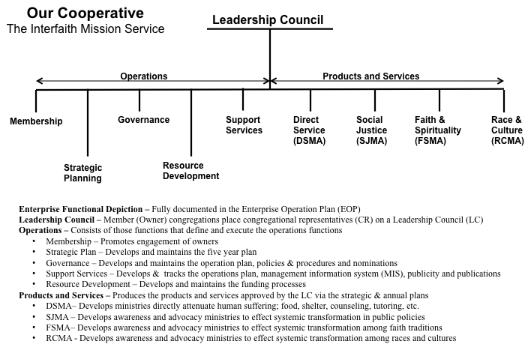
Organization

Words describing the architecture and operating concept of our cooperative.

From our Operations Manual

Organization Responsibilities – Leader Job Description – Processes

2.1.6.3 Social Justice Ministry Area (SJMA)
Specific ministries focusing on improving the quality of social justice are assigned to this category or ministry area.

The desired operating concept is for a member congregation to be a Coordinating Congregation working with other congregation as Support Congregations. The responsibilities of a coordinating congregation are defined in a Coordinating Congregation Description (CCD) document. See the Section 4.0.

The board members (referred to as ministry area managers) having oversight for the Social Justice Ministry Area (SJMA) will help identify and recruit the coordinating and support congregations.

Collaborating with the Membership Committee the SJMA shall compile a profile of the social justice ministries of our member congregations. Using this information as assessment of where further collaboration among the congregations is possible.

3.14 Board of Directors – Social Justice Ministry Area Managers Job Description

Our by-laws state that our cooperative is “a multi-faith organization whose members seek to grow and maximize their capacity to meet human needs, promote religious, racial and cultural harmony and participate in the public square to improve our community.”

Our desired operating concept is for member congregations to “Plan the work and work the plan”. In our context this phrase means that the member congregations will have a major input to the strategic plan (see the planning process in Section 4) that drives the annual plan and their representatives will approve the annual plan. To implement the annual plan the member congregations will take responsibility for major segments.

When this operating concept is implemented a member congregation would be the Coordinating Congregation and other congregations could be Support Congregations. To put this operating concept in place it generally starts with an individual that is willing to enlist the participation of his/her congregation.

The modus operandi of the board is to name two members as co-managers for each MA. This concept was put in place for assurance that MA leadership would be available at all times. The MA managers shall ensure that all of their specific ministries are implementing their plans in accordance with their section of the annual plan. This is best accomplished by holding monthly meetings of the MA.

In general the duties of the SJMA managers are to ensure that the responsibilities defined in Paragraph 2.1.5 are implemented.

More specifically and in the spirit of guidance the responsibilities of the board chair are to:
1. Ensure that all service learning opportunities within the DSMA are filled. The concept being pursued is that the ministry area (MA) managers will have a 5 – 7 member steering committee and each specific ministry within the MA will have a 7 – 9 member steering committee. The MAs will work with the board chair and the Membership SC chair to fill the SLOs.
2. Ensure that all of the SJMA participants attend the Power of We sessions.
3. Coach the leaders of the specific ministries to ensure that all sessions are effective e.g. have agenda, have their plans available, etc.
4. Become familiar with all of the processes described in Section 4 of this document. Generate other processes needed to plan and implement the DSMA ministries.
5. Ensure that all deliverables are delivered per the annual plan master schedule. Changes to the master schedule must be approved by the LC Executive Committee.
6. Ensure that the reporting process depicted in Section 4 of this document is implemented.
7. Review and update their schedule of deliverables.
8. Search for a coordinating congregation (CC) and prepare a coordinating congregation agreement (CCA); see Appendix.
Processes

From Section 4, Operations Manual

4.1 Strategic and Annual Planning

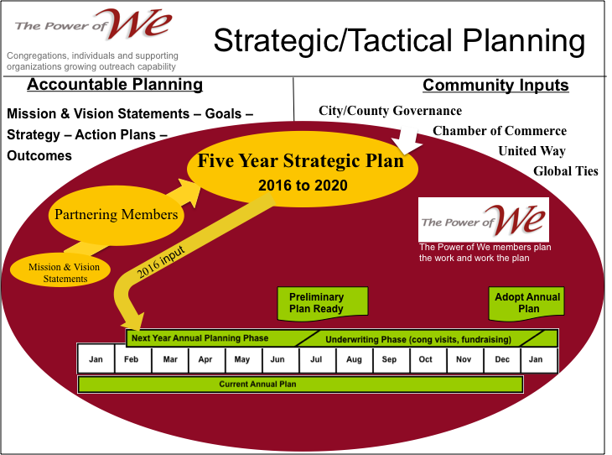
The figure on the right depicts our strategic and annual planning process. The term Accountable Planning is used to make the point that the detail planning should advance the mission and vision of the cooperative.
The steps involved to execute the strategic and annual planning processes are:
Strategic Planning
Step 1. In Feb/Mar the Strategic Planning Committee will notify the board of directors of the next year’s strategic goals.
Step 2. The committee will update the strategic plan using the guidance from, our governing documents, member congregations, community growth and needs assessments and community needs assessment, ministry areas/ministries, individual members and previous five year plan.
Step 3. The new strategic plan will be presented to the LC for approval in their November meeting.

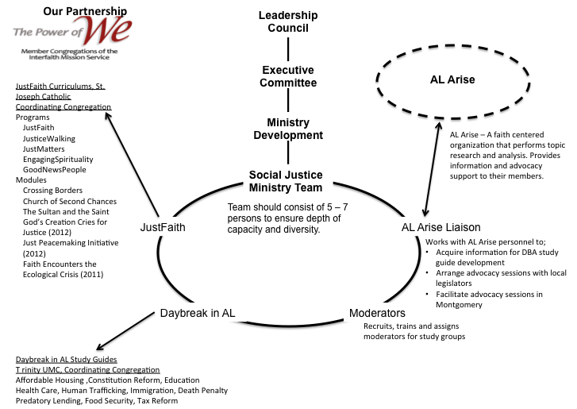

SJMA Processes

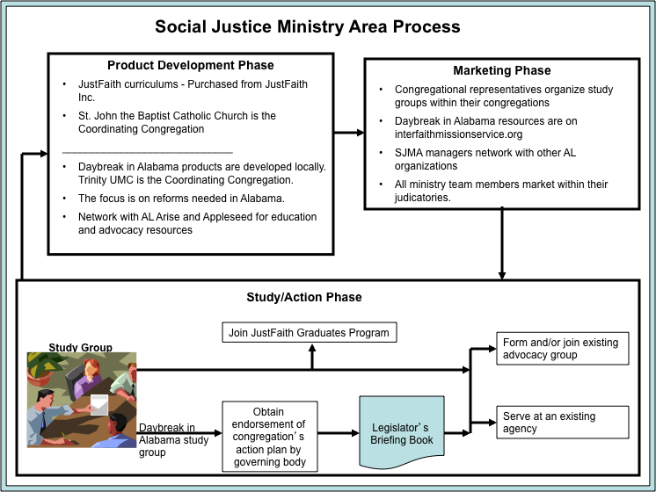

Level I Plan

Level II Plan -

Level III Plan

The Master file can be obtained from the Director of Operation. It should be reviewed at the monthly meetings and kept current. Eventually, this information will be accessible via the web and password protected.

