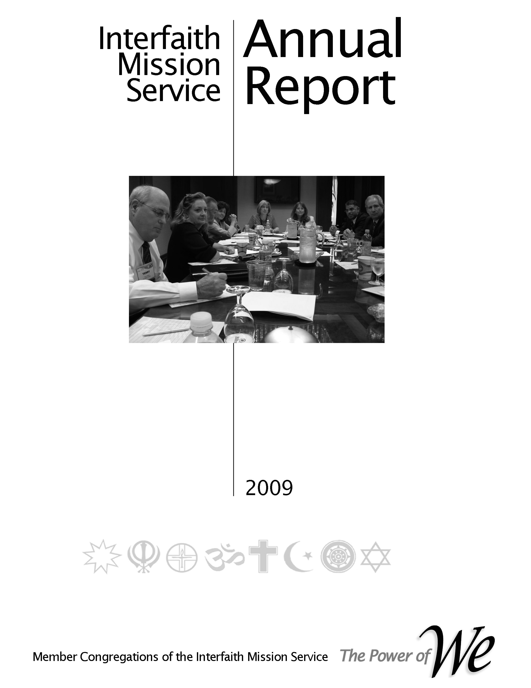
2017
Strategic Planning
Committee Handbook
http://www.illustrationsof.com/royalty-free-rf-strategic-planning-clipart-illustration-by-macx-stock-sample-79889.jpg
Doug,
There is not enough time to update all of the handbooks before our Sat retreat. Paragraphs 2.1.2 and 3.6 cover the responsibilities of the MA and the MA manager. Please make a copy to use during Session I on Saturday.

Subsequent to this event the Governance Committee will incorporate the appropriate updates.

Aladin

Table of Contents

Preface, History & Organization

Committee Responsibilities

Job Descriptions

Processes
Planning
Reporting
Operations

Preface, History & Organization

Preface
In our 2009 reorganization the primary purpose was to reconnect the faith community’s congregations structurally with the operation of their cooperative. This was accomplished by reinstituting the Leadership Council (LC) whereby every member congregation had representation on the LC. Per our by-laws the LC is responsible for setting the direction of our cooperative by approving the strategic plan, annual plan with accompanying budget, electing officers and other leaders. One of the vital committees for ensuring that these responsibilities are accomplished is the Membership Standing Committee. Its mission is to assimilate the member congregations representatives (CR) into the life of the cooperative.
Practically, that entails understanding the desires and needs of our member congregations, informing them of the service learning opportunities (SLO), schedule of events and supporting their desire to take advantage of the benefits of being an owner of our cooperative.
That is the purpose of this Outreach Planning Handbook and the resulting congregation growth plan.
When interacting with member congregations the Membership Committee member must always keep in mind that the member congregation is an owner of the cooperative. As such the benefits provided by being a member are theirs already. Consequently, the Membership Committee member should avoid terms and phrases that a we/them relationship.

History
Why organized - to moving beyond relief to building community - from the beginning the founding congregation we wanting to reach beyond relief. Although the social situation was different and the terms used were different there was an underlying feeling that the outreach ministries of the faith community must address concerns beyond food, shelter, clothes, etc. Civil rights dominated the attention of our social conditions so there was a parallel effort begun to address those issues. Today we realized that outreach is a continuum from relief to systemic transformation.

- Mission & Vision - Our mission & vision are depicted in the adjacent picture. Several years ago the LC adopted a set of maxims derived from Peter Drucker’s “Managing a non-Profit”. The first maxim stated “The mission comes first”. The others followed to complete the management process. All those providing leadership in our cooperative should remain fixated on “The mission comes first”.

Organization
Words describing the architecture and operating concept of our cooperative.

From our Operations Manual

Organization Responsibilities – Leader Job Description – Processes

2.1.2 Strategic Planning Committee
The Strategic Planning Committee is the standing committee that has the responsibility for developing and maintaining the cooperative’s five - year strategic plan. A properly functioning Strategic Planning Committee is vital to successful accomplishment of the cooperative’s mission and vision statements.
The major functions are:
- Section 4.0 Processes and Tools depicts the process for generating and updating the strategic and annual plans of the cooperative. The strategic plan will be updated annually and be presented to the Leadership Council for approval in the November meeting. This schedule is mandated by the annual planning cycle that must begin in April to have a plan available for the member congregations to use in their planning cycles.
- Develop a briefing(s) that will help member congregations understand the needs of the community and their priorities.
- There are two standard deliverables.
  - An updated five year strategic plan prepared per the process described in paragraph 4.1
  - Briefing depicting the prioritized needs of the community that is provided to the member congregations for use in planning their outreach ministries.

The Strategic Planning Committee is a committee of the Leadership Council and reports to the Leadership Council Chair. The leader of the Strategic Planning Committee is a member of the LC Executive Committee.

3.6 Strategic Planning Committee Leader Job Description

Our by-laws state that our cooperative is “a multi-faith organization whose members seek to grow and maximize their capacity to meet human needs, promote religious, racial and cultural harmony and participate in the public square to improve our community.”

Our desired operating concept is for member congregations to “Plan the work and work the plan”. In our context this phrase means that the member congregations will have a major input to the strategic plan that drives the annual plan and their representatives will approve the annual plan. To implement the annual plan the member congregations will take responsibility for major segments.

When this operating concept is implemented a member congregation would be the Coordinating Congregation and other congregations could be Support Congregations. To put this operating concept in place it generally starts with an individual that is willing to enlist the participation of his/her congregation.

In general the duties of the Strategic Planning SC Leader are to ensure that the responsibilities defined in Paragraph 2.1.1 are implemented.

More specifically they entail:

1. The Strategic Planning SC Chair should establish a steering team (7-9 persons) to lead the committee. All CRs are expected to perform the role of being the link between their congregation and the cooperatives ministries, the steering team should consist of CRs and others if needed.
2. The Chair shall be very familiar with all of the processes explained in Section 4 and will ensure that all members of his/her team are equally familiar. Of particular importance are the planning and reporting processes. Adequate and timely planning plus committed leadership are the keys to the success of our cooperative. Reporting performance establishes the creditability for financial support.
3. In 2014 there is planned a Power of We meeting on the first Thursday of each month (unless change because of a holiday or some other circumstance). All standing committees and ministry areas will attend. Breakout sessions will provide for individual ministry business. The Strategic Planning chair is responsible for ensuring their members are notified and attend.
4. A master plan for all of the activities of our cooperative. The chair is responsible for maintaining the Strategic Planning section.

11. The leader will ensure that a list of potential member congregations are maintained. The list will be prioritized from least likely to most likely to join.

12. The leader will ensure that requirements for presentation materials are provided to the Support Services Ministry Team for development.

13. The leader will recruit a member congregation to accept responsibility for implementing the functions of Membership Committee. When that occurs the leader will take the lead to develop Coordinating Congregation Description (CCD) using the format of those already in existence.
Processes

From Section 4, Operations Manual

4.1 Strategic and Annual Planning
The figure on the right depicts our strategic and annual planning process. The term Accountable Planning is used to make the point that the detail planning should advance the mission and vision of the cooperative.
The steps involved to execute the strategic and annual planning processes are:
Strategic Planning
Step 1. In Feb/Mar the Strategic Planning Committee will notify the board of directors of the next year’s strategic goals.
Step 2. The committee will update the strategic plan using the guidance from, our governing documents, member congregations, community growth and needs assessments and community needs assessment, ministry areas/ministries, individual members and previous five year plan.
Step 3. The new strategic plan will be presented to the LC for approval in their November meeting.

Level II Plan –
Goals
Goals
Identify and make contact with all interfaith organizations operating in the southeast region (TN, GA, AL, MS)
The current 2015/2019 strategic plan is a conceptual document the goal is generate a “best practice” model for future strategic planners.
Conduct a community needs listening session in Q1 to provide input to the annual plan
Provide input to the annual planning process

Activity | Jan | Feb | Mar | Apr | May | Jun | Jul | Aug | Sept | Oct | Nov | Dec
Join NA
Identify & contact other groups in our region
Select “best practice’ format and generate the plan
Goal 4
Goal 5
Goal 6

Schedule

Service Learning Opportunities - See Appendix for definition
Leader team - Seven to nine people to lead the ministry
The team members will interact with local agencies to understand the needs; do research to identify other operations in our region, make contacts with those groups, produce strategic plans
In doing so the members will be working with person of multiple races, faiths and cultures

Level III Plan

