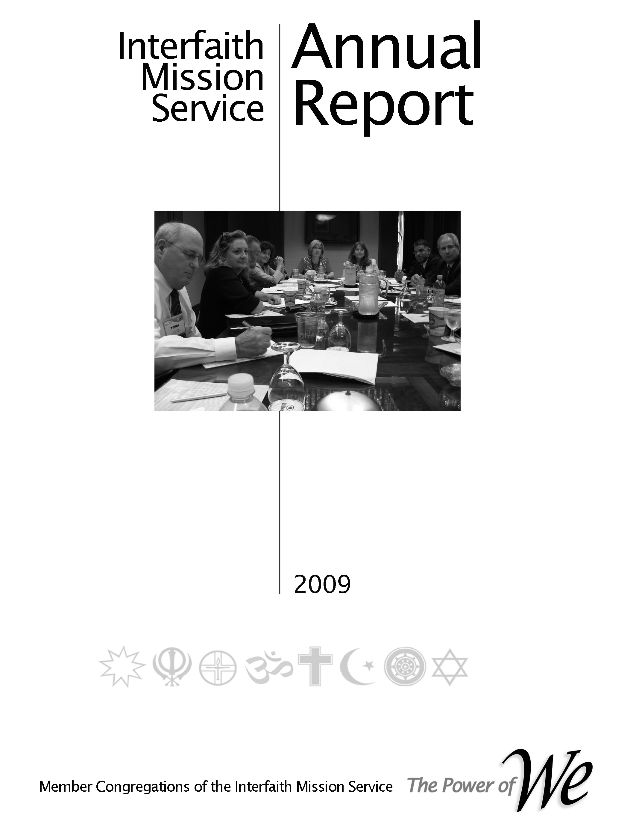

#### Support Services

**Committee Handbook**

**Table of Contents**

**Draft**

Updated – 1/4/17

**2017**

# Purpose

**Scope**

# Preface, History & Organization

# Committee Responsibilities

# Job Descriptions

# Processes

* Planning
* Reporting
* Operations

##### Annual Plan 2015

* Level II Schedule
* Catch-up Schedule
* Normal Schedule

**Purpose**

The purpose of this document is to provide an operational handbook for orienting, training and guiding the members of the Support Services Committee and others that will interact with the committee members in the course of performing their responsibilities.

**Scope**

There are two primary sources for the information herein.

1. The Operations Manual –This is the “parent” document for delineating committee responsibilities, leader and member responsibilities, processes and other pertinent information used to direct and guide the committee.
2. The Interfaith Mission Service annual plan and supporting budget – This is the “parent” document for setting forth the committee’s Level I, and II plans, budget and other pertinent information used to direct and guide the committee.

The parent documents are approved by the Leadership Council (LC) and are thus binding on the committee. Level III planning and other information must be aligned with the Operations Manual and annual plan, but does not have to be approved by the LC.

Both parent documents, as well as this document, can be accessed via <interfaithmissionservice.org>; select Admin; and then Plans and Governing Documents.

**Preface, History & Organization**

**Preface**

In our 2009 reorganization the primary purpose was to reconnect the faith community’s congregations structurally with the operation of their cooperative. This was accomplished by reinstituting the Leadership Council (LC) whereby every member congregation is represented on the LC. Per our by-laws the LC is responsible for setting the direction of our cooperative by approving the strategic and annual plans with accompanying budget, approving governance matters, and electing officers. One of the vital committees for ensuring that these responsibilities are accomplished is the Support Services Committee.

Its mission is to provide support services via four tasks.

* Planning, tracking and reporting
* Marketing/publicity
* Management Information System (MIS)
* Publication

The specific functions of these tasks are discussed in paragraph TBD.

**History**

Why organized - to moving beyond relief to building community - from the beginning the founding congregation were wanting to reach beyond relief. Although the social situation was different and the terms used were different there was an underlying feeling that the outreach ministries of the faith community must address concerns beyond food, shelter, clothes, etc. Civil rights dominated the attention of our social conditions so there was a parallel effort begun to address those issues. Today we realize that outreach is a continuum from relief services to systemic transformation.



**Mission Statement of our inter-religious cooperative, the Interfaith Mission Service**

**Our Mission**: **To strengthen and enhance our member congregations capabilities to:**

* Meet human needs,
* Participate in the public forum,
* Promote religious, racial and cultural harmony

**Vision Statement of our inter-religious cooperative, the Interfaith Mission Service**

To become globally recognized leaders in building beloved community

**Characterization of Beloved Community**

* Poverty, hunger, and homelessness are not tolerated because international standards of human decency do not allow it
* Racism and all forms of discrimination, bigotry and prejudice are replaced by an all-inclusive spirit of sisterhood and brotherhood.
* Disputes will be resolved by peaceful conflict-resolution and reconciliation of adversaries, instead of force.
* Economic inequality will be replaced by economic justice
* Mission & Vision - Our mission & vision are depicted in the adjacent picture. Several years ago the LC adopted a set of maxims derived from Peter Drucker’s “Managing a non-Profit”. The first maxim stated “The mission comes first”. The others followed to complete the management process. All those providing leadership in our cooperative should remain fixated on “The mission comes first”.

##### Organization

Our organization is designed to ensure that the member congregations are in control of the direction of the cooperative – in its strategic (long range) and tactical activities. The Operations Manual will provide the specifics.

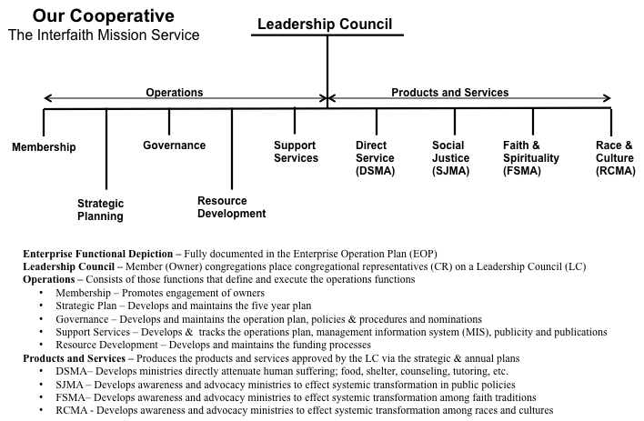

* Member congregations (often referred to as owners) select a member(s) of their congregation to represent them on our cooperative’s Leadership Council.
* The Board of Directors and five standing committees report to the Leadership Council.
* The functions of all of the organizational elements are defined in the Operations Plan. The Support Services Committee functions are repeated in this document.

**Organization Responsibilities – Leader Job Description – Processes**

**Support Services Committee –** (Extracted from the parent document; the Interfaith Mission Service Operations Plan)

Specific ministries focusing on improving the quality of our planning, marketing and management practices are assigned to this category or ministry area.

The desired operating concept is for a member congregation to be a Coordinating Congregation working with other congregation as Support Congregations. The responsibilities of a coordinating congregation are defined in a Coordinating Congregation Description (CCD) document. See the Section 4.0.

Specifically, the responsibility of the SSMA is to provide support to the leadership council via four tasks.

1. Planning, Tracking and Reporting - Generate the annual plan and supporting budget using inputs from the strategic plan and ministry areas. Provide the annual plan to the Executive Committee for submittal to the LC for approval. Status the progress of annual plan implementation and provide support where needed. Prepare the annual report depicting the accomplishments of the year
2. Marketing/Publicity - Provide marketing and publicity materials to be used by the all elements of the cooperative.
   1. Layout and content of website
   2. Monthly report content and distribution; Membership Committee will provide list of people in the congregations and individual member that should receive and electronic copy
   3. Branding standards
3. Management Information Systems - Design and maintain a web based management information system to archive historical information, capture planning and results information, archive publicity materials, and generate reports. Train the staff and volunteers to use the system.
4. Publications – Prepare documents for publication. This entails editing and formatting documents to ensure conformance with approved standards e.g. cover design, layout, etc.

The Support Services Committee is a committee of the Leadership Council and reports to the Leadership Council Chair. The leader of the Support Services Committee is a member of the LC Executive Committee

**3.5 Support Services Committee Leader Job Description**

**Processes**

# General Planning Process

# 4.1 Strategic and Annual Planning

The figure on the right depicts our strategic and annual planning process. The term Accountable Planning is used to make the point that the detail planning should advance the mission and vision of the cooperative.

The steps involved to execute the strategic and annual planning processes are:

**Strategic Planning**

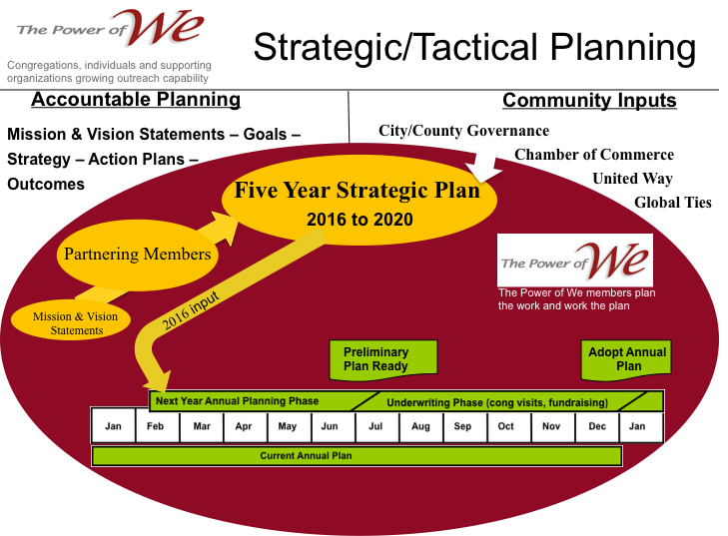Step 1. In Feb/Mar the Strategic Planning Committee will notify the board of directors of the next year’s strategic goals.

Step 2. The committee will update the strategic plan using the guidance from, our governing documents, member congregations, community growth and needs assessments and community needs assessment, ministry areas/ministries, individual members and previous five year plan.

Step 3. The new strategic plan will be presented to the LC for approval in

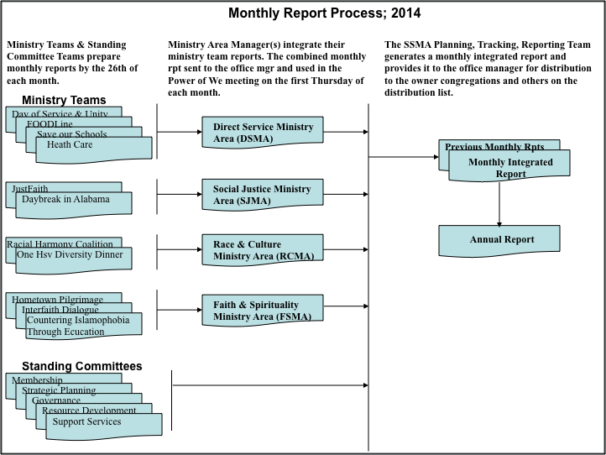**Monthly Report Process**

**5.0 Annual Plan for 2017**

**5.1 Level I Plan**

**5.2. Level II Plan –**

**5.3. Level III Plan –** See Support Services Committee Level III Plan.

**Appendix**

**Useful information for interacting with ecumenical and other faith traditions.**

This section of the handbook it to provide information about the various denominations and faith traditions useful for participating in an interfaith enterprise.

**United Methodist Congregations**

**¶120. *The Mission (Book of Discipline)***

The mission of the Church is to make disciples of Jesus Christ for the **transformation** **of the world** by proclaiming the good news of God’s grace and by exemplifying Jesus’ command to **love God and neighbor**, thus seeking the fulfillment of God’s reign and realm in the world.

The fulfillment of God’s reign and realm in the world is the vision Scripture holds before us.

The United Methodist Church affirms that Jesus Christ is the Son of God, the Savior of the world, and the Lord of all.

As we make disciples, we **respect persons of all religious faiths and we defend religious freedom for all persons**. Jesus’ words in Matthew provide the Church with our mission:

“Go therefore and make disciples of all nations, baptizing them in the name of the Father and of the Son and of the Holy Spirit, and teaching them to obey everything that I have commanded you” (Matthew 28:19-20), and **“You shall love the Lord your God with all your heart, and with all your soul, and with all your mind. . . . And you shall love your neighbor as yourself” (Matthew 22:37-39).**

**121. *Rationale for Our Mission***

This mission is our grace-filled response to the Reign of God in the world announced by Jesus. God's grace is active everywhere, at all times, carrying out this purpose as revealed in the Bible. It is *expressed* in God's covenant with Abraham and Sarah, in the Exodus of Israel from Egypt, and in the ministry of the prophets. It is fully *embodied* in the life, death, and resurrection of Jesus Christ. It is *experienced* in the ongoing creation of a new people by the Holy Spirit.

John Wesley, Phillip Otterbein, Jacob Albright, and our other spiritual forebears understood this mission in this way. Whenever United Methodism has had a clear sense of mission, God has used our Church to save persons, heal relationships, transform social structures, and spread scriptural holiness, thereby changing the world. In order to be truly alive, we embrace Jesus' mandate to love God and to love our neighbor and to make disciples of all peoples.

**Definition of the outreach ministries congregations “shall” address**

¶ 252.2 The outreach ministries of the congregation shall give attention to but not be limited to local and larger community ministries of compassion, justice, and advocacy. These ministries include church and society, global ministries, higher education and campus ministry, health and welfare, Christian unity and inter-religious concerns, religion and race, and the status and role of women.

Paragraph 252.2.b of our Book of Discipline states the following concerning outreach ministries

“The outreach ministries of the congregation shall give attention to but not be limited to local and larger community ministries of compassion, justice, and advocacy. These ministries include

1. church and society,
2. global ministries, (*interpreted to include local, state, regional as well as global)*
3. higher education and campus ministry,
4. health and welfare,
5. Christian unity and inter-religious concerns,
6. religion and race, and
7. the status and role of women.

Commentary on **¶**252 **–** There a very few congregations that can, individually conduct a robust ministry in all of these ministry areas. At the same time most congregations have members that are called to systemic ministries; reaching beyond direct service and addressing the “Why” questions. Thus, through the “Power of We” network greater impact can be realized.